Scavenger Hunt - College, Career, and Civic Life (C3) Framework
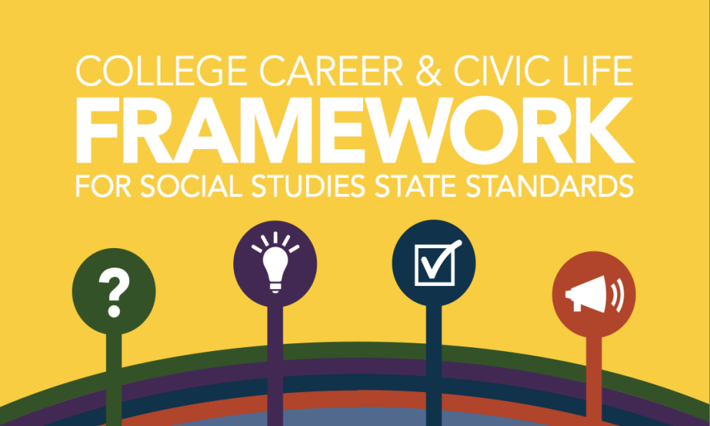
Picture Prediction: Based on the symbols included in this graphic, predict what you think might be the critical components of the C3 framework.

Introduction:
What is the purpose of the C3 framework?

How was the C3 framework created, and who were some of the partners involved in the process?

How to Read the C3 Framework: Explain these components of the C3 document.
- Inquiry Arc

- Connections to ELA/Literacy Common Core Standards

- Dimensions & Subsections

- C3 Framework Indicators & K-12 Pathways

What is included in the appendices?

What is NOT covered in the C3 framework?
The Inquiry Arc includes the following four dimensions. Explore each of these to determine what content and skills they contain.
Dimension 1 - Developing Questions and Planning Inquiries
- What are the three subsections?

- Describe the indicators and pathways for your grade level.

- What are connections to the ELA Common Core standards?

Dimension 2 - Applying Disciplinary Concepts & Tools
Civics
Add subsections in these boxes.
Civic and Political Institutions

Below each box, list the pathway
indicators for your grade level.

Economics

Geography

History

Dimension 3 - Evaluating Sources and Using Evidence
- What are the two subsections of dimension 3?

- Describe the indicators and pathways for your grade level.

- What are connections to the ELA Common Core standards?

Dimension 4 - Communicating Conclusions and Taking Informed Action
- What are the three subsections of dimension 4?

- Describe the indicators and pathways for your grade level.

- What are connections to the ELA Common Core standards?

- As you complete the scavenger hunt, reflect on any of these topics:
1. What are some things you observed about the structure and/or content of the C3 document?
2. What is new or different about the content or skills in C3?
3. What sounds similar to Common Core? ACT Quality Core? Core Content?
4. Questions or concerns?
My Thoughts and Reflections:

