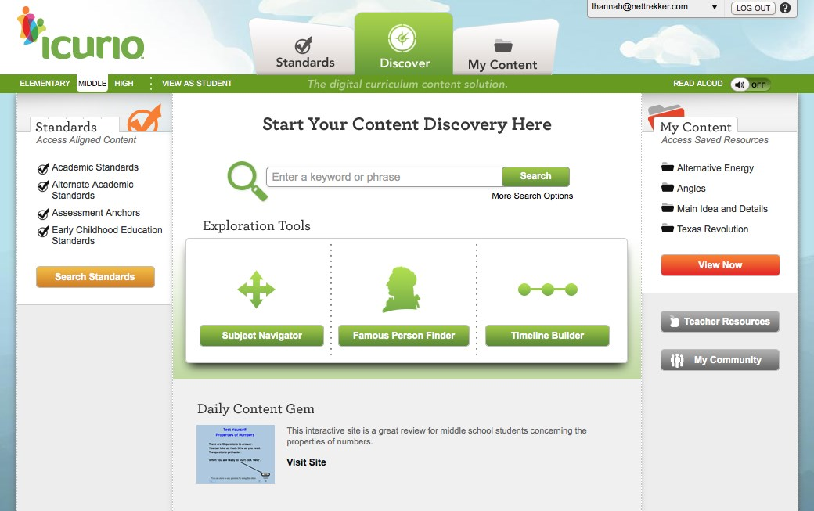

**What is****?**

* **Digital Learning Resource Library that is easy to navigate and can be utilized by teachers, students and parents when appropriate.**
* **Icurio delivers a dynamic collection of over 330,000 vetted, contextualized, standards-aligned digital learning resources from a broad range of content providers.**
* **Includes a guaranteed that each resource in the Library has cleared a 127-point certified vetting process and is expertly tagged according to:** 
  + **resource type, language, authority and subject depth, alignment to relevant standards, grade level, readability score and up to 57 defining characteristics.**
* **Icurio KVEC Learning Topics:**
  + **Personalized and Blended Learning**
  + **Future Ready Learners: Focus on 21st Century skills and information literacy skills**
  + **Early Literacy: Content specifically designed for early learners unique learning objectives**
  + **STEM: Enhance learners career readiness and study options**
  + **Reading, Writing, Listening & Speaking: Aspects of the language arts curriculum have been woven into objectives and standards for every content area**
* **Professional Learning: Knovation relies on an individual delivery plan led by experts in their fields. On-going training and support is provided to our Icurio Leads team as needed.**