3rd Grade Children’s Rights Inquiry
Kentucky Academic Standards for Social Studies (KASS) | 3.CM.1 Explain how citizens engage in democratic processes and practice civic responsibility through government.  3.CM.2 Demonstrate civic virtues, democratic principles and respect for various perspectives.
Practices of the Inquiry Cycle | Developing supporting questions, gathering relevant information, identifying and utilizing evidence, constructing viable arguments, taking public action and engaging in disciplinary thinking (civic mindedness).
What will students know and be able to do? | Students will understand that where you live influences what it means to have rights and how those rights are valued.
Potential Compelling Question
Do people around the world care about children’s rights?
Potential Stimulus for Questions
What does it mean to have rights and to care about them?
Supporting Question 1 |  | Supporting Question 2 |  | Supporting Question 3
What are children’s rights? |  | Why are children’s rights violated in some places? |  | How do people work to protect children’s rights?
Formative  Performance Task |  | Formative  Performance Task |  | Formative  Performance Task
Define the term rights, identify some of the universal rights of children, and state why these rights are important |  | Use evidence from text and statistics to write and support claims about why some children’s rights are violated around the world |  | Use evidence from sources to write and support claims about the ways that people work to protect children’s rights
Featured Sources |  | Featured Sources |  | Featured Source(s)
Serres, Alain. I Have the Right to Be a Child. Toronto: House of Anansi Press, 2009. Print.  (ISBN-13: 978-1554981496)  “For Every Child.” Video produced by UNICEF |  | Upadhyay, Ritu. “Hard at Work.” Time for Kids, World Report Edition. January 24, 2003.  Wlodarczak, Jackie. “UNICEF and You. A Focus on Girls’ Education.” TFK Extra! Supplement to Time for Kids. Fall, 2004. |  | Video Clips on the UNICEF Challenge  Marks, Madeline. “A Voice for the Voiceless.” TFK Extra! Supplement to Time for Kids. Fall, 2014.
Culminating  Performance Task | Task |  | Do people around the world care about children’s rights? Construct an argument supported with evidence that addresses the question of whether people around the world care about the rights of children.
 | Extension |  | Express these arguments through a class discussion using the “Take a Stand” protocol.
Taking Informed Action | Understand: Brainstorm a list of issues related to children’s rights around which the class might construct a public service announcement.  Assess: Determine how a public service announcement could influence the protection of children’s rights.  Act: Choose one issue and construct a public service announcement that could be submitted for broadcast on the school announcements.

Overview

Inquiry Description

This inquiry focuses on the concept of universal human rights and fair treatment of all people, through the compelling question, “do people around the world care about children’s rights?” The compelling question highlights the idea that human rights, including the right to have one’s basic needs met, are to be universally ensured and protected. Around the world, there are instances of human rights violations, as well as individuals, groups, and nations who work to protect and defend human rights. The focus on children’s rights – the idea that children have unique rights that apply to them as non-adult members of the global citizenry –gives students an opportunity to examine the idea that they have rights and to understand that they can have an impact on the world.

Three supporting questions guide students in their inquiry by introducing the concept of universal human rights while identifying some of the specific rights of children, investigating children’s rights violations, and learning about how human rights are protected by individuals and groups around the world. Through an examination of the featured sources in this inquiry, students will deepen their understandings of global human rights issues and learn how people can improve the lives of others around the world by attending to the protection of human rights.

Content Background

The concept of universal human rights implies that all people should be treated fairly and should have the opportunity to meet their basic needs. Across the globe, these rights should be protected in order to ensure fair treatment and equality of access to opportunity for all. In efforts to clarify and specify the rights of all global citizens, the United Nations adopted the Universal Declaration of Human Rights (UDHR) in 1948, and the Convention on the Rights of the Child treaty (CRC) in 1989. The CRC has been ratified by all United Nations member states, with the exception of Somalia, South Sudan, and the United States. (For more information on the CRC, see: http://www.unicef.org/crc/. For more information on the United States’ reluctance to ratify the Convention, see: http://www.economist.com/blogs/economist-explains/2013/10/economist-explains-2).
While specific rights of children are recognized and identified in international law, these laws are sometimes disregarded, resulting in the violation of children’s rights. Two such ways that children’s rights are violated around the world are in the perpetuation of child labor practices and in the unequal access and denial of rights to an education, especially for girls.
Individuals, groups, and governments around the world work to protect and defend children’s social, physical, and economic wellbeing in different ways. UNICEF is one such group that advocates for the protection of children’s rights and is actively employed in nearly every country in the world.

Content, Practices, and Literacies
A robust curriculum inquiry is going to marry the key content students need to learn with the social studies skills and practices that they need to master. The formative performance tasks represented in this inquiry build students’ content knowledge about human rights through demonstration of the associated third grade social studies practices. The first formative task focuses students’ attention on what it means for people to have rights, and on identifying some of the internationally recognized rights of children. As students discuss and explore the featured sources (Gathering, Using, and Interpreting Evidence), they also identify the efforts and roles of individuals and groups within world communities who take responsibility for the protection of children’s rights (Civic Participation).
The second formative task exposes students to instances of children’s rights violations around the world by highlighting child labor practices and unequal and denied access to education. The featured sources shed light on the impact of poverty and global economic systems on children’s lives around the world. These understandings enable students to broaden their understandings of the Key Idea while demonstrating aspects of the Economics and Economics Systems practices for Grade 3. Especially relevant are the practices around identification of goods, services, and trade in world communities. Examining how scarcity affects decisions, and the costs and benefits of economic decisions (Economics and Economic Systems) is important in building students’ understanding of why children’s rights violations occur in some places.
The third formative task highlights the roles and responsibilities that organizations and citizens around the world take in the protection of human rights. This task calls upon students to again employ the Grade 3 practices of Civic Participation through an activity that focuses on a world community issue or problem and examination of the roles of individuals and groups in social and political participation.
Evident across the three formative tasks is increasing complexity of thinking. The first task works at the identification level in that students are learning about internationally accepted definitions of rights and identifying some rights of children. The second task also has an identification element in that students are asked to identify instances of children’s rights violations, but it also prompts students to infer and make connections that explain why these violations occur in the context of global economics and inequality. In the third task, students move to examine the impact of efforts around the world to protect children’s rights, preparing them to make and support claims about how much people around the care about the issue of children’s rights in the summative task.
The New York State P-12 Common Core Learning Standards for English Language Arts & Literacy offer social studies teachers numerous opportunities to integrate literacy goals and skills into their social studies instruction. The Common Core supports the inquiry process through reading rich informational texts, writing evidence-based arguments, speaking and listening in public venues, and in using academic vocabulary that complements the pedagogical directions advocated in the New York K-12 Social Studies Framework. At the end of this inquiry is an explication of how teachers might integrate literacy skills throughout the content, instruction, and resource decisions they make. The Common Core connections are listed on the last page of this inquiry.

Staging the Compelling Question
Compelling Question | Do people around the world care about children’s rights?

Teachers may choose to begin staging the compelling question by focusing on vocabulary and context prior to introducing the question in its entirety. For instance, the teacher might ask, “what does it mean to care about something?” or “how would we know if people cared about something?” Doing so might encourage students to make connections within a more localized context, such as school and then be able to broaden that understanding to the rest of the world. For example, students might make the following connection: “If we care about our school work, it means we work hard on it and we are committed to doing it well.”

It will also be critical to begin discussing the concept of rights, and eventually, the rights of children. Teachers will want to highlight that this inquiry examines children’s rights around the world, connecting the question to the broad Grade 3 focus on world communities. This opening discussion will be especially important for English Language Learners who may have had limited exposure to words such as rights within the compelling question.

Students may discuss their ideas about rights and the notion of “caring about something” as a whole class or in small groups, and then represent their ideas through drawing or writing as the teacher sees fit. It might be helpful to plan for this introductory discussion before beginning Formative Performance Task 1 in order to address vocabulary needs or gaps in knowledge and share student ideas. Ideally, students can return to these ideas throughout the formative tasks. Students should be able to analyze and articulate how their ideas and perspectives change and develop as a result of the inquiry as it unfolds.

Formative Performance Task 1

Supporting Question 1 | What are children’s rights?
Formative Performance Task | Define the term rights, identify some of the universal rights of children, and state why these rights are important
Featured Source(s) | Source A: Excerpts from I Have the Right to Be a Child by Alain Serres  Source B: “For Every Child” Video produced by UNICEF
Conceptual Understandings | Across global communities, governments and citizens alike have a responsibility to protect human rights and treat others fairly (3.8a)
Social Studies Practices | Gathering, Using, and Interpreting Evidence  Civic Participation

Supporting Question

As students begin to think about and investigate this supporting question and the featured sources, they will explore an internationally accepted definition of the specified rights of children. In order to ultimately build an argument in response to the compelling question, students will need to have background knowledge about the concept of universal rights. They will need to know that people from many countries around the world have agreed in writing to uphold particular rights through international agreements. The teacher may wish to introduce students to the rights protected by the CRC by explaining that the document aims to protect children’s social, physical, and economic wellbeing. In understanding each of these terms (social, physical, economic, and wellbeing), students will be able to categorize certain rights and better conceptualize the violation of these rights.

Formative Performance Task

Formative Performance Task 1 (Children’s Rights Task) asks students to define “what is a right?” and to illustrate and describe the importance of some of the internationally accepted rights of children. Students will gather this information from Sources 1A and 1B and through a class discussion about rights (Civic Participation). To show that meaning is evident (Gathering, Using, and Interpreting Evidence Practice), students will draw examples illustrating selected children’s rights and explain why the chosen rights are important. The teacher may wish to frame this task for students with an audience and purpose in mind (e.g., compilation of student pages into a book to be read by another class in the school). They can also allow students to cut and paste images from a magazine or other source in lieu of drawing. These activities will contribute to the summative task by providing students with the opportunity to demonstrate growing background knowledge about children’s rights in order to eventually make claims about how rights are violated or protected when asked to consider scenarios presented in Formative Performance Tasks 2 and 3.

Children’s Rights Task

Directions – Part 1: Think about the book we read, the video we watched, and our class discussion. Answer the question below, including details and vocabulary words.

What are rights?

Directions – Part 2: Choose at least 2 of the Rights of Children that we have discussed and read about. These should be rights that are included in the Convention on the Rights of the Child. Draw a picture showing each of these rights, and explain why they are important.

As I child, I have the right to ________________________________________________. This right is important because ________________________________________________________________________.

As a child, I have the right to ________________________________________________. This right is important because ________________________________________________________________________.

Featured Sources

Featured Source 1A is the picture book, I Have the Right to Be a Child. Source 1B is a short video produced by UNICEF that features photographs of children from around the world juxtaposed with short phrases and sentences describing the rights of children. Utilization of these sources (or others like them) will allow students to grapple with the concept of rights and identify some of the internationally recognized rights of children.
Featured Source A, the picture book I Have the Right to Be a Child, introduces students to some of the specific rights afforded to children by the CRC in language and illustrations that are accessible for third graders. From the inside cover:

In this beautifully illustrated book a young child describes what it means to have rights – from the right to food, water, and shelter, to the right to go to school, to be free from violence, to breathe clean air, and more. These rights belong to every child on the planet, whether they are ‘black or white, small or big, rich or poor, born here or somewhere else. And it is of the greatest importance that we all respect these rights.

This book introduces readers to the concept of human rights, specifically the rights of children as put forth in the United Nations Convention on the Rights of the Child. The teacher may wish to use this book, or parts of it, to launch a class discussion about what it means to have rights. After previewing the book, the teacher may wish to select excerpts and specific pages to read aloud to highlight some of the rights of children, or may choose to expose children to the book in its entirety. Students should be given the opportunity in partners or small groups to discuss the text and grapple with the notion of rights and how rights often need to be protected in order to be extended to all peoples. Pages 13-16 offer an opportunity for students to connect this concept to their background knowledge about fairness and struggles of diverse people. After sufficient discussion, students should engage in Formative Performance Task 1 using details from the text to construct their written response to Part 1 and their illustrations in Part 2.

The book also will be helpful in scaffolding Formative Performance Task 2 if page 12 (on a child’s right to education), pages 13-16 (on equal treatment of girls/boys, and diverse peoples), and pages 21-22 (on a child’s right to education and freedom from exploitive labor practices) are included in the excerpts chosen to be read aloud. The teacher may also wish to show students the short, online video trailer featuring this book as it features a young girl reading the book aloud and a short commentary at the end.

Featured Source B is a video produced by UNICEF. This video highlights the importance of children’s rights as documented in the Convention on the Rights of the Child. Photographs from children around the world are displayed in a slideshow with written captions. Teachers should have the class watch this video three times. The first time through, students can watch the video with attention to the images. The second time, teachers may choose to read the captions aloud to the class as they are displayed on the screen and pause the video at various points to discuss vocabulary related to human rights. This discussion of vocabulary can include specific attention to the words, inalienable (students will encounter this word again in fourth grade while studying the Declaration of Independence), guarantee, and ensure. Teachers are encouraged to employ a range of academic vocabulary pedagogical strategies in teaching these words. While other words in the video may be unfamiliar to students (such as enshrined), it is suggested that discussion focus on these three words in particular, because they will be especially helpful for students to understand and use in their own writing about the Children’s Rights topic. The final time watching the video, students can be asked to name various rights that they see displayed in the images or take notes for a purpose on a graphic organizer.

Supporting Question 1 Featured Source A | Serres, Alain. I Have the Right to Be a Child. Toronto: House of Anansi Press, 2009. Print.  (ISBN-13: 978-1554981496)  A short trailer video featuring parts of this book can be found at: http://www.youtube.com/watch?v=PclSfAugvws

Supporting Question 1 Featured Source B | “For Every Child” Video produced by UNICEF  https://www.youtube.com/watch?v=Mmy9MpwyKnQ

Formative Performance Task 2

Supporting Question 2 | Why are children’s rights violated in some places?
Formative Performance Task | Use evidence from text and statistics to write and support claims about how some children’s rights are violated around the world
Featured Source(s) | Source A: Upadhyay, Ritu. “Hard at Work.” Time for Kids, World Report Edition. January 24, 2003.  Source B: “UNICEF and You. A Focus on Girls’ Education.” TFK Extra! Supplement to Time for Kids. Fall, 2004.
Conceptual Understandings | Across time and places, communities and cultures have struggled with prejudice and discrimination as barriers to justice and equality for all people (3.8b).
Content Specifications | Students will examine prejudice and discrimination and how they serve as barriers to justice and equality for all people (from 3.8b).
Social Studies Practices | Gathering, Using, and Interpreting Evidence  Chronological Reasoning and Causation  Economics and Economic Systems

Supporting Question

As students begin to think about and investigate this supporting question and the featured sources, they will learn about specific examples from around the world in which children’s rights have been violated. They will examine how discrimination and poverty play a role in exacerbating conditions for some children and they will learn about some of the complex reasons children’s rights violations exist, even though the Convention on the Rights of the Child has been ratified by most nations on earth.

Formative Performance Task

The second formative performance task (Children’s Rights Violations Task), calls on students to use evidence from various sources (Gathering, Using, and Interpreting Evidence) to demonstrate their growing knowledge about children’s rights, including why they are violated in some places around the world. Students must identify examples of these violations, where they occur, and provide evidence from the text that explains why these violations occur in those places. The selected sources allow for students to develop skills related to Chronological Reasoning and Causation by building their understanding of how events and patterns of continuity and change in world communities have sometimes resulted in children’s rights violations, such as denial of the right to an education. Also relevant are the practices related to Economics and Economic Systems whereby students will learn about how scarcity and decisions about the use of resources have impacted the lives of children, sometimes resulting in the perpetuation of child labor practices.

Although teachers may have students complete the Children’s Rights Violations Task as individuals, there should be opportunities for students to work in pairs and small groups to partner read and discuss the sources. Offering students opportunities to verbalize their emerging understandings beforehand will help them think about and respond to the written task. If a class anchor chart documenting evidence and inferences is created, students may be permitted to consult this chart as they complete the task.

A possible extension to this task could be the inclusion of a journal writing or illustration activity in which students reflect on what they have learned about child rights violations around the world. Doing so will allow students the opportunity to draw conclusions and express feelings they might have about the emerging topic. The products of their reflections could also serve as a potential resource for the taking informed action activities at the conclusion of the inquiry.

Children’s Rights Violations Task

All children have the right to… | This right is violated for some children in… | Evidence from my sources:  What are some reasons that this violation happens here?
Example: Go to school and not work in dangerous jobs | Banana plantations in Ecuador | Many families in Ecuador are poor and they need their children to work in banana plantations so they can survive.

Featured Sources

Sources 2A and 2B allow children to uncover examples of rights violations and some of the reasons that they exist in some places around the world. Featured Source 2A presents information about child labor practices in Ecuador by highlighting the challenges faced by young workers, Wilbur and Alejandro. The source indicates that child labor practices are widespread throughout the world, including within the United States, by citing the United Nations estimate that around 250 million children worldwide are forced to go to work. This source makes important connections to poverty and global economic situations that contribute to the perpetuation of child labor practices. It also includes an insert highlighting the history of child labor in the United States. It will be important to highlight with students that children’s rights violations have been a part of our history as Americans, and that children’s rights violations still occur in the United States today. This realization, coupled with the knowledge that the United States is one of only three countries (the others being Somalia and South Sudan) yet to ratify the Convention on the Rights of the Child, reinforces that this issue is relevant both around the world, and here at home.

Independent reading of this text source may be challenging for some third-grade readers. To scaffold the reading and comprehension of this text, teachers may choose to have students read small sections of the text several times, in pairs, small groups, or as a whole class, stopping to discuss and compare what they learn to what they have already learned about internationally accepted definitions of children’s rights. They may also wish to establish more concrete examples and non-examples of children’s rights violations by exploring some of the information presented in greater detail (e.g., How is working on a banana plantation different from helping around the house with chores?) A class anchor chart could be co-constructed to document evidence and inferences found in the text, noting such details as “Alejandro’s father wants him to be able to go to school, but the family doesn’t have enough money for food, so he needs to go to work.”

Featured Source 2B provides students with information about denied and unequal access to education for some children, particularly girls, around the world. Included in the text are primary source quotes from girls from countries such as Bangladesh, Boliva, Sudan, Chad, and India who are faced with this barrier to equality and the impact it has on their lives.

One way to allow children time to think, share, and react to these sources thoroughly would be through the utilization of a Chalk Talk/Silent Discussion protocol. After ample time to read the source independently, small groups of children are provided with the source mounted on a large piece of blank paper. Children are told not to speak aloud to one another, but to use writing and drawing to react to the source within the blank space around it. One child might begin the exercise by circling the sentence, “the United Nations estimates that 250 million kids around the world are forced to work” from Featured Source A and writing, “Wow! There are a lot of kids who have to work. I wonder if they are ever able to play.” Another child might continue the “silent conversation” by drawing an arrow from the first child’s comment to the sentence about Ecuadorian banana plantation workers that says, “their average workday lasts 12 hours!” and writing, “If these kids work for 12 hours they probably don’t have time for anything else in their day.” This routine can be modeled first by the teacher and 1-2 students or another adult so that students learn how to participate. Over time, repeated usage of this routine to digest sources results in richer written dialogue. Students should be given time to return to their posters after consulting additional sources to allow the conversation to evolve.

Sources 2A and 2B are featured because they offer an opportunity to highlight the kinds of sources that teachers may use to teach the inquiry and how to use them. They are not meant to be a final or exhaustive list.

Additional/alternative sources include:

- Newsela.com articles (content available at multiple Lexile levels of reading complexity). Teachers may choose to use these articles in a variety of ways. The more complex (higher Lexile) versions could be used as teacher read alouds or as a way of enriching instruction for highly capable readers, while the less complex (lower Lexile) versions could be scaffolded to allow for greater accessibility for developing readers:
  - (560L) “Many Afghan children must work hard for low pay to help feed their families.” Los Angeles Times, adapted by Newsela staff: April 29, 2014.
  - (700L) “Many Afghan children work hard for low pay; school is just a daydream.” Los Angeles Times, adapted by Newsela staff: April 29, 2014.
  - (950L) “School is just a dream for many Afghan children, working hard for low pay.” Los Angeles Times, adapted by Newsela staff: April 29, 2014.

- “Hard at Work.” Video: Time for Kids. Photojournalist Larry Price visits Burkina Faso to report on working conditions of children in gold mining camps (www.timeforkids.com/photos-video/video/hard-work-117456). Teachers may choose to show selected parts of this video.

- Excerpted statistics from UNICEF on children’s rights violations (such as those included below). Teachers may scaffold exploration of relevant statistics by integrating mathematics lessons on fractions and percentages as applicable.

Excerpts of Child Labor Information and Selected Statistics
- UNICEF estimates that 158 million children between the ages of 5-14 are engaged in child labor as of 2006.
- More than one-third of children in sub-Saharan Africa work.
- The International Labor Organization estimates that more than two-thirds of all child labor is agricultural. Children in rural areas – girls in particular – begin agricultural labor as young as 5-7 years old.
Country | Continent | Percentage of boys ages 5-14 who work | Percentage of girls ages 5-14 who work | Types of work done by children
Colombia | South America | 6% | 4% | Cutting flowers, mining emeralds and gold
Ecuador | South America | 9% | 4% | Growing and picking bananas
Ghana | Africa | 57% | 58% | Harvesting cacao
India | Asia | 12% | 16% | Weaving carpet, making bricks, working as nannies
Mongolia | Asia | 35% | 36% | Mining coal

Source: UNICEF 2008

Supporting Question 2 Featured Source A | Upadhyay, Ritu. “Hard at Work.” Time for Kids, World Report Edition. January 24, 2003.

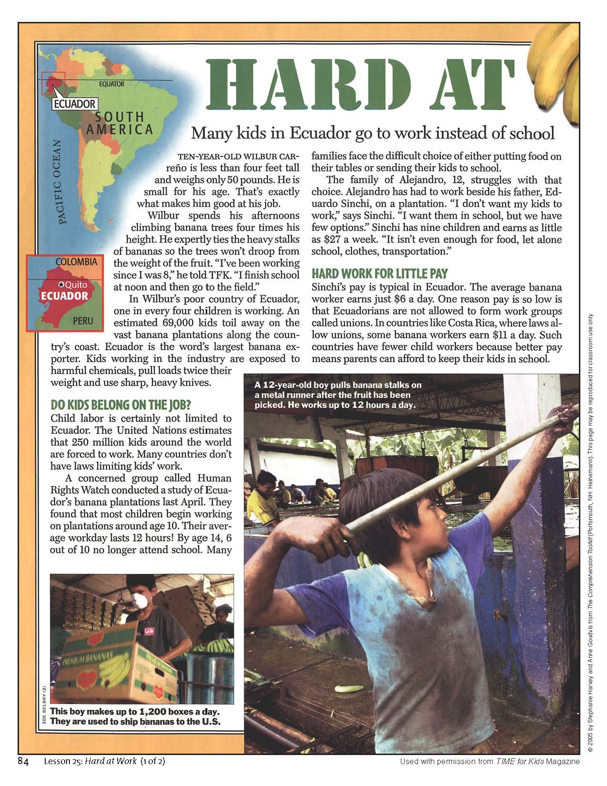
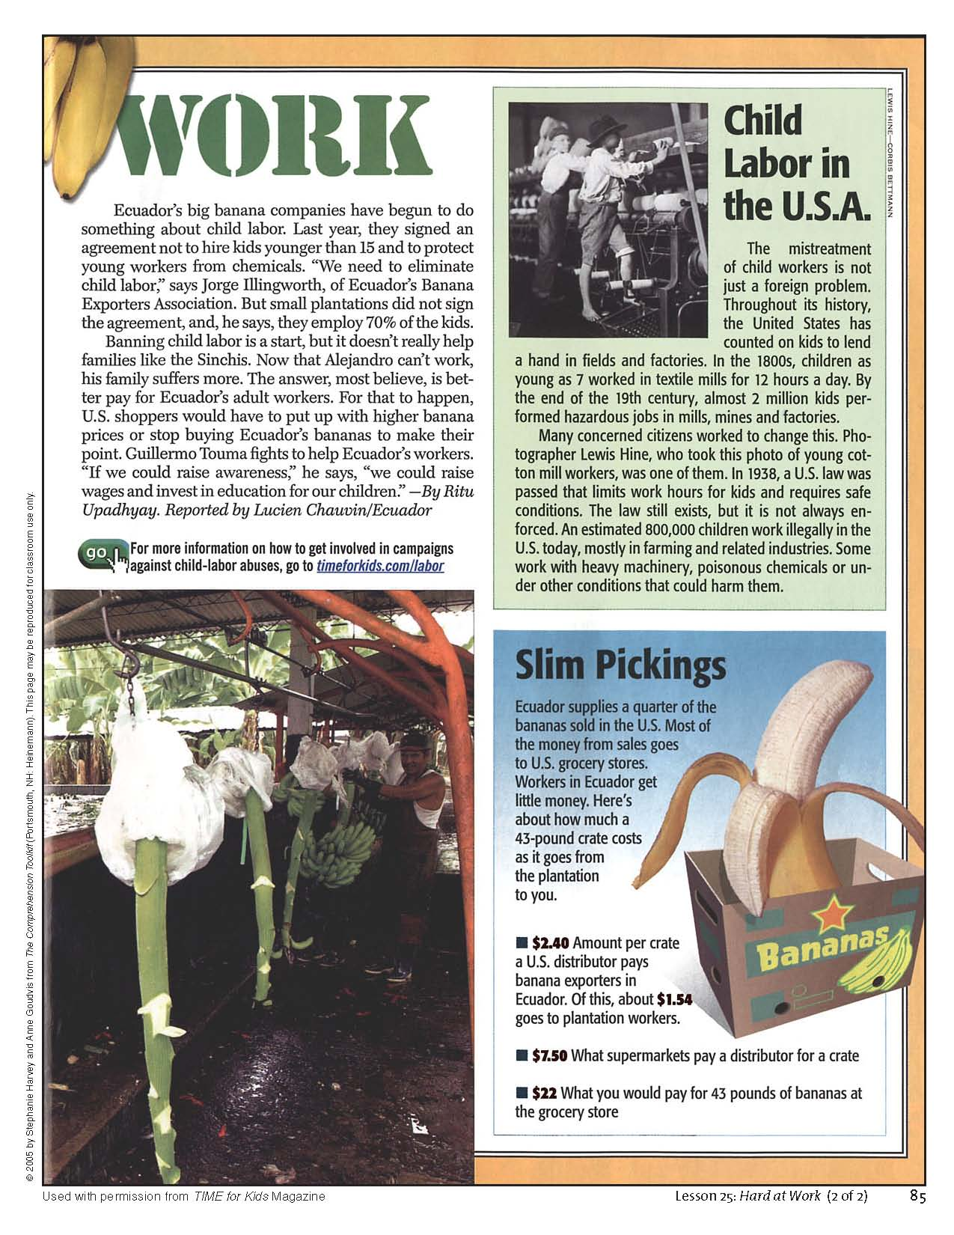

Supporting Question 2 Featured Source B | “UNICEF and You. A Focus on Girls’ Education.” TFK Extra! Supplement to Time for Kids. Fall, 2004.

Formative Performance Task 3

Supporting Question 3 | How do people work to protect children’s rights?
Formative Performance Task | Use examples from text, video, maps and graphs to write and support claims about the ways that people work to protect children’s rights around the world
Featured Source(s) | Source A: Video Clips on the UNICEF Challenge (http://schools.trickortreatforunicef.org/challenge)  Source B: Marks, Madeline. “A Voice for the Voiceless.” TFK Extra! Supplement to Time for Kids. Fall, 2014. (Excerpt)
Conceptual Understandings | Across global communities, governments and citizens alike have a responsibility to protect human rights and to treat others fairly (3.8a).  When faced with prejudice and discrimination, people can take steps to support social action and change (3.8c).
Content Specifications | Students will examine the extent to which governments and citizens have protected human rights and treated others fairly (3.8a).  Students will investigate steps people can take to support social action and change (3.8c).
Social Studies Practices | Gathering, Using, and Interpreting Evidence  Civic Participation

Supporting Question

The supporting question asks students to investigate and categorize several examples of humanitarian aid in order to explain how some people around the world work to protect children’s rights. The question is meant to be inclusive of the efforts of individuals, groups, nations, non-profit groups, and multinational organizations.

Formative Performance Task

The third formative performance task (Protecting Children’s Rights Task) asks students to gather evidence to make and support claims about ways people protect children’s rights (Civic Participation). Students may categorize different ways (Gathering, Using, and Interpreting Evidence) people protect children’s rights and provide several examples for each category. This task pushes students closer to the ultimate goal of constructing an argument derived from the compelling question in the subsequent summative task.

Protecting Children’s Rights Task

What are some ways people work to protect children’s rights? | Examples I found in my sources:
Example: Some people work to protect children’s rights by donating to charities. | People donate money to the UNICEF challenge which is used to provide children with food, safe water, and medicine.

Featured Sources

For this task, students will draw a second time upon the text sources used in Formative Task 2 (Featured Sources 2A and 2B, and any additional sources used), as well as two new sources—Featured Sources 3A, and 3B. Students will re-read Featured Sources 2A and 2B, this time documenting examples of ways people work to protect children’s rights.

Featured Source 3A showcases five videos of schoolchildren participating in various activities to benefit UNICEF through the Kids Helping Kids Challenge. Teachers are encouraged to select 2-3 or more of these videos to show the class. The goal is to expand students’ understanding of who can work to protect children’s rights from government and organizations run by adults.

Featured Source 3B includes excerpted sections from an online article about Malala Yousafzai. (The entire article is available online at http://www.timeforkids.com/news/voice-voiceless/186496 ). The excerpted text describes how Malala has been awarded both the Liberty Medal and the Nobel Peace Prize for her work in raising awareness about children struggling to receive an education around the world. Teachers may want to read this text aloud in a large or small group setting so that they can provide scaffolding and assistance as necessary. Children can conduct subsequent independent reads of the excerpted text as they complete the formative task.

Sources 2A, 2B, and Sources 3A and 3B,are featured for this task because they offer an opportunity to highlight the kinds of sources that teachers may use to teach the inquiry and how to use them. They are not meant to be a final or exhaustive list.

Additional/alternative sources include:

- http://www.unicefusa.org/youthaction . This website highlights “3 Fun and Easy Ways” that kids can participate in fundraising efforts for UNICEF. It includes links to explore more information and graphics (example below) depicting ways that money raised can be spent to benefit kids around the world.

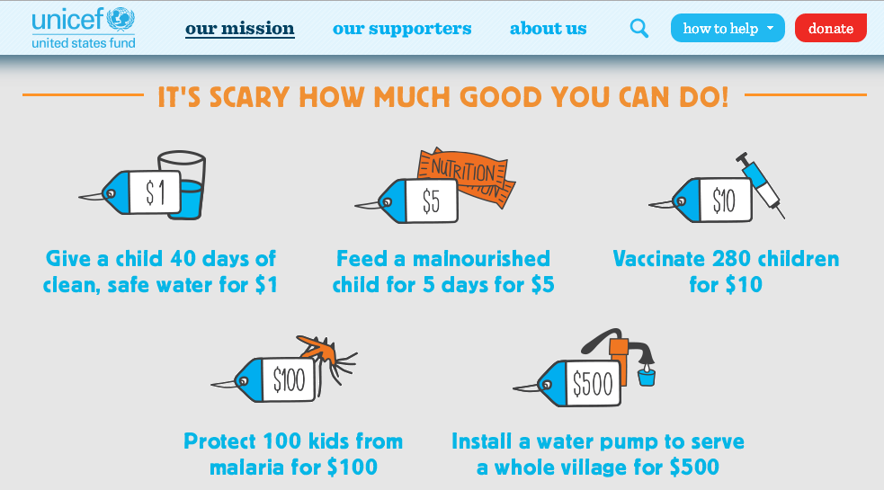

- Abouraya, Karen Leggett. Malala Yousafzai: Warrior with Words. Great Neck, NY: Starwalk Kids Media. Print.

- Excerpts from vision and mission statements of nonprofit and nongovernmental organizations working to protect children’s rights. With attention to the local community and cultural considerations, the teacher might select 3-5 mission or vision statements such as those included below in order to emphasize the role and impact that various groups play around the world. Examples include:
  - The Child Labor Coalition (http://stopchildlabor.org/) - “Our Mission: Promoting health, safety, education and well-being for working minors. Pursuing an end to child labor exploitation.”
  - Feed the Children (http://www.feedthechildren.org/about/) – “Our Vision: Create a world where no child goes to bed hungry. Our Mission: Providing hope and resources for those without life’s essentials.”
  - Kids Against Hunger (http://kidsagainsthunger.org/) – “Our Mission at Kids Against Hunger is to significantly reduce the number of hungry children in the USA and to feed starving children throughout the world. We ship meals to starving children and their families in over 60 countries through partnerships with humanitarian organizations worldwide. We need your help to end world hunger.”
  - Schoolgirls Unite! (http://www.schoolgirlsunite.org/About ) - “Our Mission is to tackle prejudice against girls worldwide and expand their freedom and opportunities through education and leadership.”

Supporting Question 3 Featured Source A | Source A: Video Clips on the UNICEF Challenge (http://schools.trickortreatforunicef.org/challenge)

Supporting Question 3 Featured Source B | Source B: Marks, Madeline. “A Voice for the Voiceless.” TFK Extra! Supplement to Time for Kids. Fall, 2014. (Excerpt)

A Voice for the Voiceless:

Pakistani youth activist Malala Yousafzai receives the 2014 Liberty Medal
Oct 23, 2014
By TFK Kid Reporter Madeline Marks

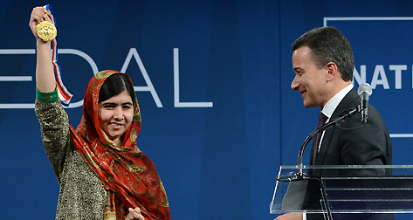
WILLIAM THOMAS CAIN—GETTY IMAGES
Hundreds of people flocked to the heart of Philadelphia, Pennsylvania, on October 21 to witness Malala Yousafzai, 17, receive the National Constitution Center’s 2014 Liberty Medal. Malala, who also recently won the Nobel Peace Prize, is a Pakistani youth activist who has become a champion for children and their right to an education.
After receiving the medal, Malala addressed the crowd. “It’s not just a golden medal which you wear,” she said. “It’s hope, it’s courage, and it’s support.” She added, “I accept this award on behalf of all the children around the world who are struggling to get an education.” Malala plans to donate the $100,000 prize that comes with the Liberty Medal to her home country of Pakistan to further education for young people.
The History of the Medal
The first Liberty Medal was awarded in 1989 to Lech Walesa, who went on to become the president of Poland. Twenty-six years later, Malala is the youngest-ever recipient, and the seventh to also win the Nobel Peace Prize. Malala and Walesa are both people who spread the concepts of freedom, equal rights, and liberty through their work.
Not only does Malala have a powerful voice that speaks for children across the world, but she is a child, too. Malala’s age is one of the many reasons why she was chosen to receive the Liberty Medal, and why young people can learn so much from her.
As the youngest recipient of both the Nobel Peace Prize and the Liberty Medal, Malala has already displayed for the world her capabilities and plans for the future. Malala speaks out for the 57 million children worldwide who do not have the opportunity to attend school. She calls for countries to come together in peace, to lay down their weapons, and to use their money for education and schools, not wars.
Malala is an inspiring role model to many, and her accomplishments are extraordinary, especially considering she is just 17 years old. She reminds us that we are stronger than any challenge in our life. The world looks forward to seeing what she accomplishes next as she continues to be a voice for voiceless children of the world.

Summative Performance Task

Summative Performance Task | Argument | Do people around the world care about children’s rights? Construct an argument supported with evidence that addresses the question of whether people around the world care about children’s rights.
 | Extension | Express these arguments through a class discussion using the “Take a Stand” protocol.

For this inquiry, rather than have students express their evidence-based arguments through formal, written essays, teachers may wish to have students sketch out their responses to the compelling question by using a large note card or half-sheet of paper. One side can be dedicated either to the position that people around the world do care about children’s rights, or to the position that they do not. While many students will gravitate toward one or the other end of that continuum, teachers should encourage them to consider more nuanced arguments such as, “some people care about children’s rights, but more people need to.” The other side of the paper is then reserved for listing the evidence that supports the argument chosen.

This kind of less formal written task offers two benefits. For students, such a task is less dependent on good writing skills than an essay is. Essay writing is very important, but it takes considerable practice and skill and, if this inquiry is taught early in the school year, teachers may want to focus more on the key elements of the argument-evidence relationship than on students’ abilities to write fully formed responses. The benefit to teachers is that they can quickly see if students are grasping the content of the inquiry through the statement of their argument and the evidence that they cite to support it.

Students’ arguments likely will vary, but could include any of the following:

- People around the world do not care enough about children’s rights because millions of children do not attend school and many are forced to work.

- People around the world do not care enough about children’s rights because they buy bananas and other foods from countries that use children as farm workers.

- People around the world do care about children’s rights because they work together in organizations like UNICEF to help build schools and give school supplies to children who need them.

- People around the world do care about children’s rights because they raise money and donate it to charities that provide food and medicine for kids.

It is possible for students to find support for any of these arguments in the sources provided and through their analysis of the sources.

Rubrics play an important role in setting expectations for students and guiding the evaluation of students' work. When preparing students for constructing an argument (in whatever form it takes), teachers may provide students with rubrics that focus on the strength of the claims and evidence in the argument as well as the quality and craft of students' writing. For elementary students, teachers should consider using the Short-Response Holistic Rubric for younger students and the Extended-Response Holistic Rubric for older students (see pages 13-14 in the Common Core English Language Arts Test Guide at file:///Users/sggrant/Desktop/grade-3-ela-guide.pdf).

Extension
In addition, or as an alternative to, the summative task, teachers can lead students through a class discussion. There are many ways to stage a student discussion; the “Take a Stand” protocol offers a structured way of doing so.

In a “Take a Stand” activity, the classroom is arranged so that one end is reserved for those who believe that “people around the world care a great deal about children’s rights.” The other end is reserved for those who believe that “people around the world care very little about children’s rights.” Students then arrange themselves physically at points along the continuum. Students should not take an extensive amount of time choosing their positions, but should concentrate on engaging in dialogue with those nearby about the content of their arguments and the evidence they would cite to support them. As the discussions unfold, some students may realize that they want to modify their original arguments and move to different positions along the continuum. Should they do so, teachers can encourage them to articulate their reasons for the shift.

Taking Informed Action

Compelling Question | Do people around the world care about children’s rights?
Taking Informed Action | Understand: Brainstorm a list of issues related to children’s rights around which the class might construct a public service announcement.  Assess: Determine how a public service announcement could influence the protection of children’s rights.  Act: Choose one issue and construct a public service announcement that could be submitted for broadcast on the school announcements.

Taking informed action can manifest in a variety of forms and in a range of venues. Students may express action through discussions, debates, surveys, video productions, and the like; these actions may take place in the classroom, in the school, in the local community, across the state, and around the world. The three activities described in this inquiry represent a logic that asks students to a) understand the issues evident from the inquiry in a larger and/or current context, b) assess the relevance and impact of the issues, and how they might be able to help protect children’s rights, and c) act in ways that allow students to demonstrate agency in a real-world context.

For this inquiry, students build background knowledge to understand the concept of universal human rights in general and children’s rights in particular. Students will learn that children are not treated equally well around the world and that a range of individuals and groups are attempting to ensure that all children have access to basic rights. The videos included as sources in Formative Task 3 provide concrete examples of how students themselves can participate in taking informed action. These examples will likely give students the confidence and initiative required to bring actionable efforts to fruition.

In the understand section of the Taking Informed Action component, students can draw on the knowledge and expertise they developed through the inquiry in order to brainstorm a list of issues that they feel could benefit from the construction of a public service announcement (e.g., an appeal to students and teachers in their school to support UNICEF). Once students have generated a list of possible issues, teachers can help them assess that list by leading them through an analysis of how they might be able to become involved in the protection of children’s rights through the development of a public service announcement. . Although either of the first two activities could nicely wrap up this inquiry, teachers and students may want to follow through and act by choosing an issue to focus on and creating an actual public service announcement. That announcement could then be made public through the medium of school announcements, newsletters, and the like.

Common Core Connections

Social studies teachers play a key role in enabling students to develop the relevant literacy skills found in the New York State P-12 Common Core Learning Standards for English Language Arts and Literacy. The Common Core emphasis on more robust reading, writing, speaking and listening, and language skills in general and the attention to more sophisticated source analysis, argumentation, and the use of evidence in particular are evident across the Toolkit inquiries.

Identifying the connections with the Common Core Anchor Standards will help teachers consciously build opportunities to advance their students’ literacy knowledge and expertise through the specific social studies content and practices described in the annotation. The following table outlines the opportunities represented in the Grade 3 Inquiry through illustrative examples of each of the Standards represented.

Compelling Question | Do people around the world care about children’s rights?
Common Core Anchor Standard Connections
Reading | CCSS.ELA-LITERACY.CCRA.R.1 Read closely to determine what the text says explicitly and to make logical inferences from it; cite specific textual evidence when writing or speaking to support conclusions drawn from the text.  See Formative Performance Task 2: Students identify examples of human rights violations, where they occur, and evidence from the text that explains why these violations occur in those places.  CCSS.ELA-LITERACY.CCRA.R.4 Interpret words and phrases as they are used in a text, including determining technical, connotative, and figurative meanings, and analyze how specific word choices shape meaning or tone.  See Formative Performance Task 1: Students draw examples illustrating selected children’s rights from their reading of Featured Source A.
Writing | CCSS.ELA-LITERACY.CCRA.W.1 Write arguments to support claims in an analysis of substantive topics or texts using valid reasoning and relevant and sufficient evidence.  See Formative Performance Task 3: Students gather evidence to make and support claims about ways people protect children’s rights  CCSS.ELA-LITERACY.CCRA.W.5 Develop and strengthen writing as needed by planning, revising, editing, rewriting, or trying a new approach.  See Summative Performance Task: As students take positions in the Take A Stand activity, they may realize that they want to modify their original arguments and move to different positions along the continuum.
Speaking and Listening | CCSS.ELA-LITERACY.CCRA.SL.1 Prepare for and participate effectively in a range of conversations and collaborations with diverse partners, building on others' ideas and expressing their own clearly and persuasively.  See Summative Performance Task: Students draw on the knowledge and expertise they developed through the inquiry in order to participate in the Take a Stand Protocol, speaking to peers about their argument in response to the compelling question.  CCSS.ELA-LITERACY.CCRA.SL.6 Adapt speech to a variety of contexts and communicative tasks, demonstrating command of formal English when indicated or appropriate.  CCSS.ELA-Literacy.CCRA.SL.5 Make strategic use of digital media and visual displays of data to express information and enhance understanding of presentations.  See Taking Informed Action: Students choose an issue on which to focus on and create a public service announcement that can be broadcast through the medium of school announcements, newsletters, online forums, and the like.
Language | CCSS.ELA-Literacy.CCRA.L.4 Determine or clarify the meaning of unknown and multiple-meaning words and phrases by using context clues, analyzing meaningful word parts, and consulting general and specialized reference materials, as appropriate.  See Featured Source 1B: Words such as inalienable, guarantee, and ensure will be important to discuss, define and use in writing together.

Appendix A: Children’s Rights Inquiry Vocabulary

Term | Definition
Human Rights | Expectations of opportunities that all humans should experience
Children’s Rights | Those opportunities to which all children should have access
Human Rights Violations | Infringement on a the pursuit of a human right
Universal Declaration of Human Rights | An expression of the expectations that all humans should experience crafted by the United Nations in 1948
Convention on the Rights of the Child treaty | The 1989 United Nations agreement outlining the civil, political, economic, social, health and cultural expectations that all children should experience
Universal Rights | The idea that human rights should be acknowledged throughout the world
Inalienable Rights | The idea that human rights cannot be taken away
Guarantee | To pledge or promise that certain conditions will be met
Ensure | To make sure or provide for
UNICEF | A United Nations agency concerned with the welfare of children around the world
Discrimination | Unfair treatment based on one or more group characteristics
Child Labor | The practice of having children work in order to provide for their families
Humanitarian Aid | Assistance offered to people whose basic needs are not being met

