Grade 7: Great Compromise
Kentucky Academic Standards for Social Studies (KASS) | 7.CM.2 Compare deliberate processes for making decisions and evaluating conclusions as an individual and in groups.  7.HT.14 Create an argument about the past, while acknowledging opposing claims, that is supported by relevant evidence generated from historical sources.
Practices of the Inquiry Cycle | Gathering relevant information, identifying and utilizing evidence, developing and creating claims and counterclaims, constructing viable arguments, addressing options and proposing solutions.
What will students know and be able to do? | Students will understand that while compromise resolves disputes, often those involved will have to give up certain demands.
Potential Compelling Question
Is compromise always fair?
Potential Stimulus for Questions
What is compromise? How are compromises made in the classroom different from compromises made in government?
Supporting Question 1 |  | Supporting Question 2 | Supporting Question 3 | Supporting Question 4
How was representation determined under the Articles of Confederation? |  | What was the Virginia Plan? | What was the New Jersey Plan? | How did the Connecticut Plan break the impasse?
Formative  Performance Task |  | Formative  Performance Task | Formative  Performance Task | Formative  Performance Task
Write a description for how states were represented in the Congress under the Articles of Confederation. |  | Write a summary of the Virginia Plan highlighting the impact on large and small states. | Write a summary of the New Jersey Plan highlighting the impact on large and small states. | Write a claim with evidence about how the Connecticut Plan broke the gridlock at the Constitutional Convention.
Featured Source |  | Featured Source | Featured Source | Featured Source
Source A: Excerpt from Articles of Confederation  Source B: Cartoon, When did the Articles of Confederation Start? |  | Source A: Madison’s Notes on the Debates in the Federal Convention May 29, 1787 – The Virginia Plan  Source B: Diagram of the Virginia Plan  Source C: Chart of U.S. population in 1790 | Source A: Madison’s Notes on the Debates in the Federal Convention June 15, 1787 – The New Jersey Plan  Source B: Diagram of the New Jersey Plan | Source A: Madison’s Notes on the Debates in the Federal Convention June 16, 1787 – Comparison of the Virginia and New Jersey plans  Source B: Madison’s Notes on the Debates in the Federal Convention June 15, 1787 – The Connecticut Plan is approved

Culminating  Performance Task | Task | Is compromise always fair? Construct an argument (e.g., detailed outline, poster, essay) that discusses whether or not the Great Compromise was fair to both less-populated and more-populated states using specific claims and relevant evidence from historical sources while acknowledging competing views.
 | Extension | Using the “Federalist No. 10”, research Madison’s views on factions. Construct inferences from this reading about the similarities and differences of factions to modern day political parties, while considering the role of compromise.
Taking Informed Action | Understand: Investigate an issue that requires compromise over representation in a school or community setting (e.g. representation on a student council for the school).  Assess: Determine the benefits and setbacks for various approaches to representation.  Act: Create a plan that balances the needs of both sides and share it with students and leaders in the school.

Overview

Inquiry Description
This inquiry leads students through an investigation of the Great Compromise using various sources related to its adoption. The Great Compromise was the pivotal breakthrough of the 1787 Constitutional Convention. The convention originally was formed to revise the weak Articles of Confederation; however, it quickly took on the massive task of designing a new federal government. While the work of the convention was relatively quick, May 25 to September 17, 1787, it was not without considerable debate, disagreement, and ultimately compromise. The July 16th “Great Compromise” agreement on the Connecticut Plan regarding the structure of the government was perhaps the most consequential compromise. By investigating the compelling question, students will examine the structure of government under the Articles of Confederation, investigate the two proposals (Virginia and New Jersey plans) for a new arrangement, and analyze the role of the Connecticut Plan and Great Compromise in the development of the United States Constitution. By completing this inquiry, students will begin to understand the importance of compromise in democracies.

NOTE: This inquiry is expected to take four to six 55-minute class periods. The inquiry time frame could expand if teachers think that their students need additional instructional experiences (i.e., supporting questions, formative tasks, sources). Inquiries are not scripts so teachers are encouraged to modify and adapt them in order to meet the needs and interests of their particular students.

Structure of the Inquiry
In addressing the compelling question, “is compromise always fair?” students will work through a series of supporting questions, performance tasks, and sources in order to construct an argument with evidence and counter evidence from a variety of sources. The inquiry concludes with students taking informed action on a related issue in a classroom and/or community setting.

Supporting Question 1
The supporting question, “how was representation determined under the Articles of Confederation?” helps establish the foundational understanding of the competing views of large and small states regarding representation in Congress that is needed to understand the eventual Great Compromise. This question asks about the original arrangement for representation in the unicameral (one house) legislature under the Articles of Confederation. The formative task calls on students to write a description for how states were represented in the Congress under the Articles of Confederation.
The sources for this question include an excerpt from the Articles of Confederation and a cartoon that describes some of the problems facing the United States under the Articles of Confederation.

Supporting Question 2
The second supporting question, “what was the Virginia Plan?” is an essential component in understanding the eventual Great Compromise. The Virginia Plan put forward a scheme for a new government that proposed a bicameral (two house) Congress with representation in each house determined by population. Thus, larger states would have more members in the two houses of Congress. This formative task asks students to write a summary of the Virginia Plan with consideration for how large state and small state constituents would view this plan for government. The sources for this formative task include James Madison’s description of the Virginia Plan from his Notes on the Debates in the Federal Convention, a diagram of the Virginia Plan, and a chart of the U.S. population in 1790. By completing the summary, students will understand how representation was to be determined in the Virginia Plan and infer how different states reacted to the plan.

Supporting Question 3
The third supporting question, “what was the New Jersey Plan?” is also an essential component in understanding the Great Compromise. The New Jersey Plan, a response to the Virginia Plan from small state representatives, put forward a plan for a unicameral (one house) Congress with equal representation of states and no regard to population. The plan kept in place the arrangement for Congress in effect under the Articles of Confederation, but expanded the authority of Congress. This formative performance task asks students to write a summary of the New Jersey Plan with consideration for how large state and small state constituents would view this plan. The sources for this formative task include James Madison’s description of the New Jersey Plan from his Notes on the Debates in the Federal Convention and a diagram of the New Jersey Plan. By completing the summary, students will expand their understanding of how representation was to be determined in the New Jersey Plan and infer how different states reacted to the plan.

Supporting Question 4
The fourth supporting question, “how did the Connecticut Plan break the impasse?” asks students to extend their knowledge about the debate on the design of federal government for the United States. The question focuses on the compromise effort in the Connecticut Plan to break the impasse between large states whose representatives favored the Virginia Plan and small states whose representatives favored the New Jersey Plan. The formative performance task asks students to use their knowledge from the previous formative performance tasks along with new information about the Connecticut Plan to write a claim with evidence about how the Connecticut Plan broke the impasse at the Constitutional Convention. The sources for this formative task include James Madison’s description of the plan from his Notes on the Debates in the Federal Convention and a summary of the differences between the Virginia and New Jersey plans from James Wilson (delegate to the Constitutional Convention from Pennsylvania). Based on what they have learned at this point about the Virginia, New Jersey, and Connecticut plans, students should write a claim about the prospects for success of the Connecticut Plan. Students will deepen their knowledge about the various compromises and how they related to one another.

Summative Assessment
At this point in the inquiry, students have examined representation in the Articles of Confederation and the three major plans proposed at the Constitutional Convention. Students should be expected to demonstrate the breadth of their understandings and their abilities to use evidence from multiple sources to support their distinct claims. In this task, students construct an evidence-based argument using multiple sources to answer the question, “is compromise always fair?” It is important to note that students’ arguments could take a variety of forms, including a detailed outline, poster, or essay.

Students’ arguments likely will vary, but could include any of the following:

- The Great Compromise was fair to all sides because it balanced the needs of states with large and small populations.
- The Great Compromise gave too much power to less-populated states by making representation in the Senate equal regardless of population.
- The Great Compromise gave too much power to heavily-populated states by making representation in the House of Representatives) based on population.

Students have the opportunity to Take Informed Action by drawing on their understandings of the Great Compromise to consider an issue related to representation in their school or community. To understand more about the issue, students investigate an issue that requires compromise over representation in a school or community setting (e.g. representation on a student council for the school). To assess the issue, students determine the benefits and setbacks for various approaches to representation. To act, students create a plan that balances the needs of both sides and share it with other students and leaders in the school.

Supporting Question 1 Featured Source A | Excerpt from Articles of Confederation (1777)

Article V

For the more convenient management of the general interests of the united states, delegates shall be annually appointed in such manner as the legislature of each state shall direct, to meet in Congress on the first Monday in November, in every year, with a power reserved to each state to recall its delegates, or any of them, at any time within the year, and to send others in their stead, for the remainder of the Year.

No State shall be represented in Congress by less than two, nor by more than seven Members; and no person shall be capable of being delegate for more than three years, in any term of six years; nor shall any person, being a delegate, be capable of holding any office under the united states, for which he, or another for his benefit receives any salary, fees or emolument of any kind.

Each State shall maintain its own delegates in a meeting of the states, and while they act as members of the committee of the states.

In determining questions in the United States, in Congress assembled, each state shall have one vote.

Freedom of speech and debate in Congress shall not be impeached or questioned in any Court, or place out of Congress, and the members of congress shall be protected in their persons from arrests and imprisonments, during the time of their going to and from, and attendance on congress, except for treason, felony, or breach of the peace.

Source: http://www.ourdocuments.gov/doc.php?doc=3&page=transcript

Supporting Question 1 Featured Source B | Cartoon, When did the Articles of Confederation Start?

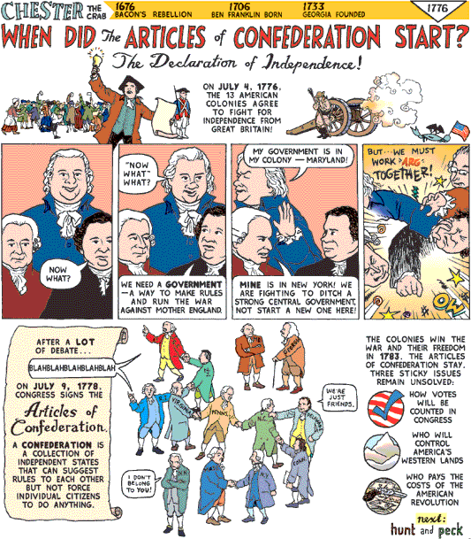

Source: http://www.chestercomix.com/

Supporting Question 2 Featured Source A | Notes on the Debates in the Federal Convention May 29, 1787 – The Virginia Plan

The Notes of Debates in the Federal Convention of 1787 was James Madison’s daily record of the debates during the Constitution Convention in Philadelphia. This excerpt was recorded on May 29, 1787. It was on this day that the Virginia Plan or Randolph resolutions were presented to the delegates.

Madison’s Notes  Tuesday May 29, 1787  Mr. RANDOLPH then opened the main business. He expressed his regret, that it should fall to him, rather than those, who were of longer standing in life and political experience, to open the great subject of their mission.  Mr. RANDOLPH then proposed as conformable to his ideas the following resolutions, which he explained one by one.  - The Articles of Confederation ought to be so corrected and enlarged as to accomplish the objects proposed by their institution; namely, "common defense, security of liberty and general welfare."  - The rights of suffrage in the National Legislature ought to be proportioned to the Quotas of contribution, or to the number of free inhabitants, as the one or the other rule may seem best in different cases.  - The National Legislature ought to consist of two branches [houses].  - The members of the first branch of the National Legislature ought to be elected by the people of the States.  - The members of the second branch of the National Legislature ought to be elected by those of the first, out of a proper number of persons nominated by the individual Legislatures  - Each branch [house] ought to possess the right of originating Acts [laws];  - A National Executive be instituted; To be chosen by the National Legislature; and that besides a general authority to execute the National laws, it ought to enjoy the Executive rights vested in Congress by the Confederation.  - The Executive and a convenient number of the National Judiciary, ought to compose a Council of revision with authority to examine every act of the National Legislature before it shall operate.  - A National Judiciary be established to consist of one or more supreme tribunals, and of inferior tribunals to be chosen by the National Legislature. | Historical Context  Edmund Randolph was a delegate from Virginia. Other Virginia delegates had more experience, but Randolph was selected to present the ideas of the Virginia delegation because he was such a good speaker.  The Constitutional Convention was called to alter the Articles of Confederation, not to replace them.  Under the Articles of Confederation, each state had one vote in the Congress regardless of population.  The Articles of Confederation had only one house in the legislature.  The first branch refers to what we call today the House of Representatives.  The second branch refers to the Senate. The 17th amendment led to people directly voting for their senators after 1913.  The House of Rep. has sole authority to originate laws related to funding.  Citizens vote for the president of the United States, but an electoral college ultimately chooses the president.  The delegates to the convention decided against a Council of revision.  There was no federal judicial branch under the Articles of Confederation.

Source A: http://avalon.law.yale.edu/18th_century/debates_529.asp

Supporting Question 2 Featured Source B | Diagram of the Virginia Plan

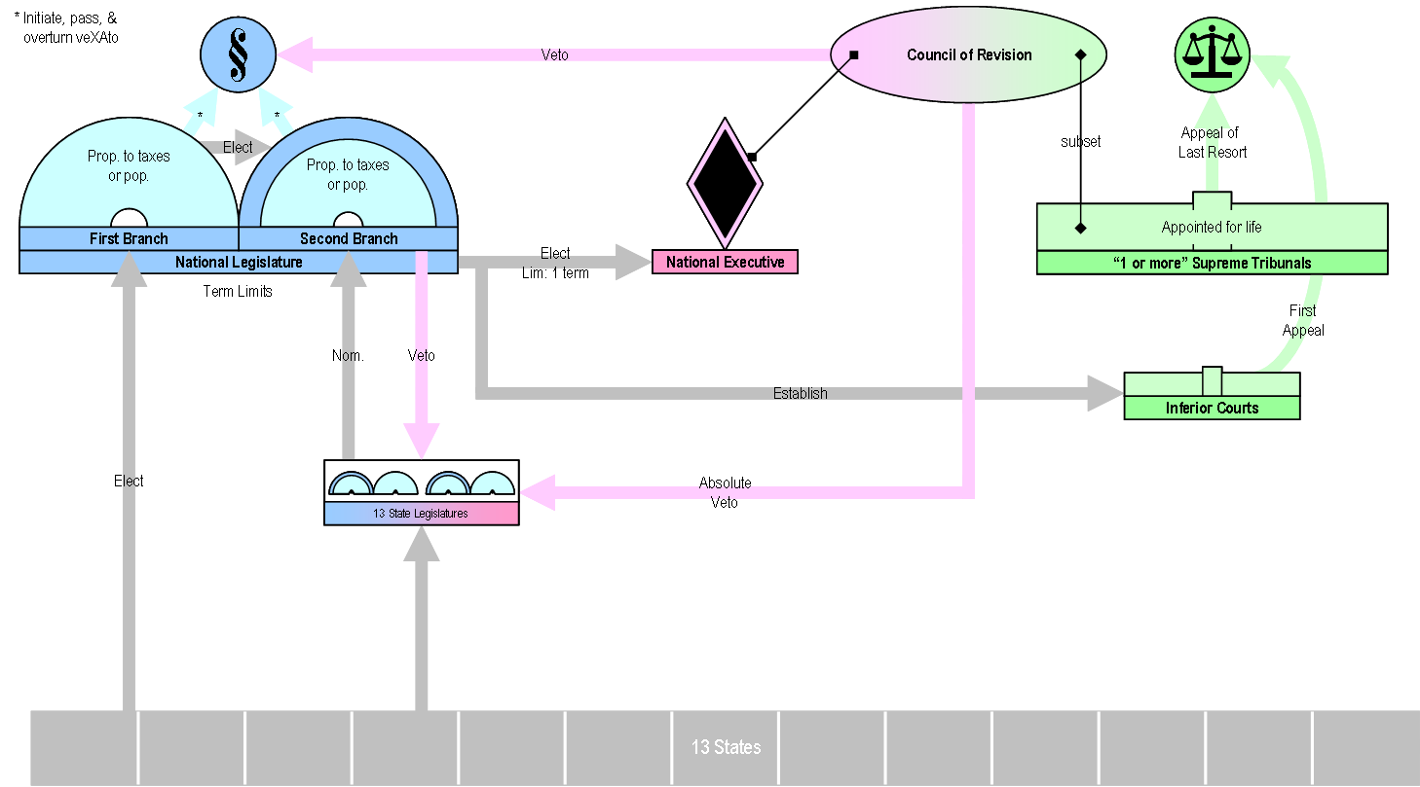

Source: http://commons.wikimedia.org/wiki/File:Virginia_Plan.png

Note to permission firm: We would like to recreate this in a simpler form if possible.

Supporting Question 2 Featured Source C | Chart of U.S. population in 1790

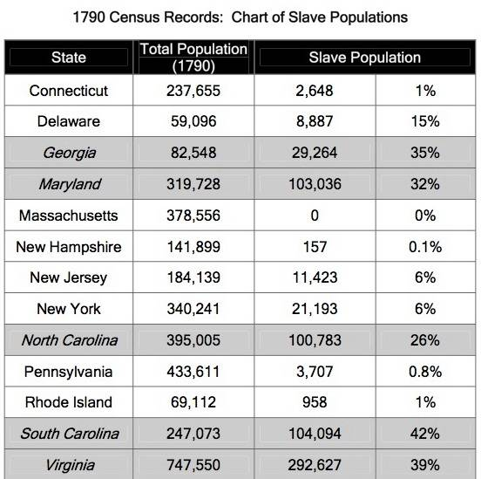

Note- although this census data comes from after the Constitutional Convention of 1787, it was selected for this inquiry as it is assumed to be a fairly accurate representation of population figures in 1787.

Source: http://mrkash.com/activities/slavery.html
Supporting Question 3 Featured Source A | Notes on the Debates in the Federal Convention May 29, 1787 – The New Jersey Plan

The Notes of Debates in the Federal Convention of 1787 was James Madison’s daily record of the debates during the Constitution Convention in Philadelphia. This excerpt was recorded on June 15, 1787. It was on this day that the New Jersey Plan or Patterson resolutions were presented to the delegates. The New Jersey Plan sought to update parts of the Articles of Confederation but made no changes to the unicameral (single house) structure of Congress with equal representation for the states.

Madison’s Notes  Friday June 15, 1787  Mr. PATTERSON, laid before the Convention the plan which he said several of the delegates wished to be substituted in place of that proposed by Mr. Randolph.  The propositions from New Jersey moved by Mr. Patterson were in the words following.  - The articles of Confederation ought to be so revised, corrected and enlarged, as to render the federal Constitution adequate to the exigencies of Government, and the preservation of the Union.  - In addition to the powers vested in the United States in Congress, by the present existing articles of Confederation, they be authorized to pass acts for raising a revenue, by levying a duty or duties on all goods or merchandizes of foreign growth or manufacture, imported into any part of the United States: to pass Acts for the regulation of trade & commerce as well with foreign nations as with each other.  - The U. States in Congress be authorized to elect a federal Executive to consist of ____ persons; that the Executives besides their general authority to execute the federal acts ought to appoint all federal officers not otherwise provided for, and to direct all military operations.  - A federal Judiciary be established to consist of a supreme Tribunal the Judges of which to be appointed by the Executive, and to hold their offices during good behavior.  The States of New Jersey and Delaware were opposed to a national government because its patrons considered a proportional representation of the States as the basis of it. The eagerness displayed by the members opposed to a national government from these different motives began now to produce serious anxiety for the result of the Convention. Mr. Dickenson said to Mr. Madison, You see the consequence of pushing things too far. Some of the members from the small States wish for two branches in the General Legislature, and are friends to a good National Government; But we would sooner submit to a foreign power than submit to be deprived of an equality of suffrage, in both branches of the legislature, and thereby be thrown under the domination of the large States. | Historical Context  William Patterson was a delegate at the Constitutional Convention from New Jersey who would later sign the Constitution. New Jersey, despite having a large population today, had a relatively small population in 1787.  The states, with the exception of Rhode Island, sent a total of 55 delegates to Philadelphia to fix the Articles of Confederation, not to write a plan for a new system of government.  Under the Articles of Confederation, the federal government had no way to tax or regulate trade.  The Electoral College, not Congress, elects the president. Today, the president does in fact appoint federal officers and does direct the military as commander in chief.  The Articles of Confederation did not include a federal supreme tribunal or court.  The New Jersey Plan sought to update parts of the Articles of Confederation but made no changes to the unicameral (single house) structure of Congress with equal representation for the states.

Source: http://avalon.law.yale.edu/18th_century/debates_615.asp

Supporting Question 3 Featured Source B | Diagram of the New Jersey Plan

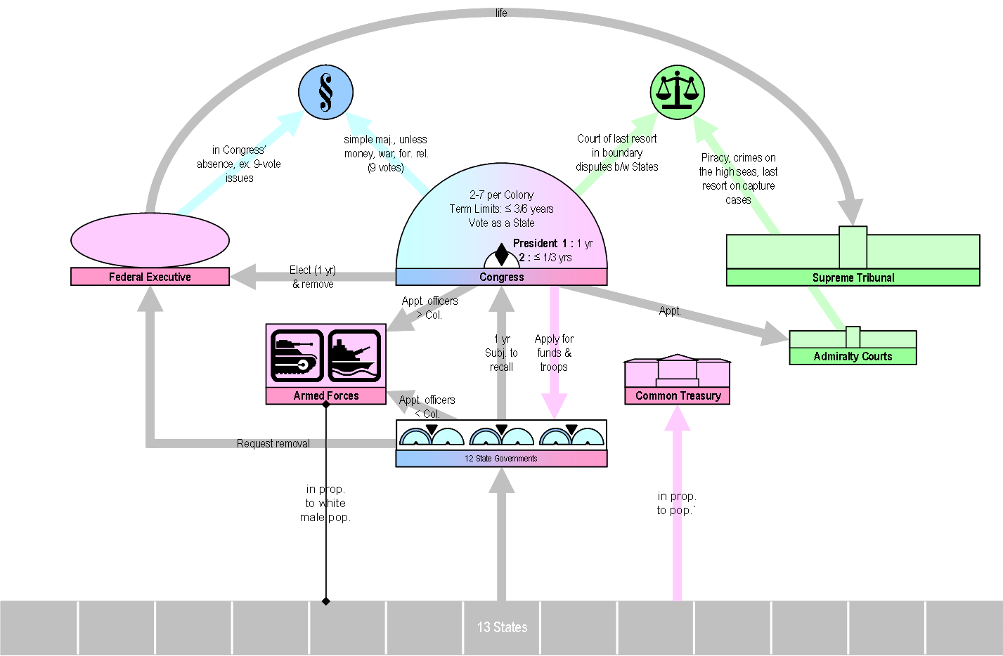

Source: http://commons.wikimedia.org/wiki/File:New_Jersey_Plan.png
Note to permission firm: We would like to recreate this in a simpler form if possible.
Supporting Question 4 Featured Source A | Notes on the Debates in the Federal Convention, July 5, 1787 – The Connecticut Plan is introduced

The Notes of Debates in the Federal Convention of 1787 was James Madison’s daily record of the debates during the Constitution Convention in Philadelphia. This excerpt was recorded on July 5, 1787. It was on this day that Elbridge Gerry of Connecticut reported on a plan for settling the differences among delegates regarding representation as put forward in the Virginia and New Jersey plans.
Madison’s Notes  THURSDAY July 5th 1787  Mr. GERRY delivered in from the Committee appointed on Monday last the following Report. That the subsequent propositions be recommended to the Convention on condition that both shall be generally adopted. | Historical Context  Elbridge Gerry served as a Connecticut delegate to the Constitutional Convention and chairman of a committee that created the Connecticut Plan. Later in life, he would go on to become Vice President under Madison, but perhaps is best known for having a political term named after him-- gerrymandering-- which is a practice of altering voting districts into often bizarre shapes.
- That in the first branch of the Legislature each of the States now in the Union shall be allowed one member for every 40,000 inhabitants: that each State not containing that number shall be allowed one member: that all bills for raising or appropriating money, and for fixing the Salaries of the officers of the government of the United States shall originate in the first branch of the Legislature, and shall not be altered or amended by the second branch: and that no money shall be drawn from the public Treasury but in pursuance of appropriations to be originated in the first branch  - That in the second branch each State shall have an equal vote.  Mr. GHORUM observed that as the report consisted of propositions mutually conditional he wished to hear some explanations touching the grounds on which the conditions were estimated.  Mr. GERRY. The Committee were of different opinions as well as the delegates. They agreed to the Report merely in order that some ground of accommodation might be proposed. | The first branch of the legislature is the House of Representative.  The total population of the country in 1787 was less than four million people. The largest state at the time, Virginia, had 400,000 free persons and 250,000 enslaved persons.  Today, each state gets one member in the House per 650,000 inhabitants. Today, there is a total of 435 representatives.  The second branch is the Senate. Each state gets two senators. Today, there is a total of 100 senators.
Source: http://avalon.law.yale.edu/18th_century/debates_705.asp

Supporting Question 4 Featured Source A | Notes on the Debates in the Federal Convention June 16, 1787 – Comparison of the Virginia and New Jersey plans

Below is modified text from James Madison’s record of James Wilson’s comparison of the Virginia and New Jersey plans as recorded on June 16, 1787. This text below was modified from the original by adding modern spelling and by removing some text.

Madison’s Notes  Saturday June 16, 1787  MR. WILSON entered into a contrast of the principal points of the two plans so far he said as there had been time to examine the one last proposed. These points were  - In the Virginia plan there are two and in some degree three branches in the Legislature: in the plan from New Jersey there is to be a single legislature only.  - Representation of the people at large is the basis of the one. The State Legislatures, the pillars of the other  - Proportional representation prevails in one: equality of suffrage in the others.  - A single Executive Magistrate is at the head of the one, a plurality is held out in the other.  - In the one the majority of the people of the United States must prevail in the other a minority may prevail. | Historical context  James Wilson served as a Pennsylvania delegate to the Constitutional Convention. He was well respected by his peers and was a very vocal delegate. He is best known for proposing the Three-Fifths Compromise to settle the issue of whether or not to count slaves towards each state’s population.  The Virginia Plan called for representation based on population. The New Jersey Plan called for equal representation, as had been the case with the Articles of Confederation.  Individual citizens did not get the right to vote for senators directly until 1913.  Wilson is describing the basic goals of the Virginia and New Jersey Plans.  The New Jersey Plan was more of a proposal to change the Articles of Confederation, rather than to create a new form of government.  The Virginia plan favored the majority of people, as the numbers of Americans living in heavily-populated states far outnumbered those living in less-populated states. The New Jersey plan might have allowed the minority living in less-populated states to always have their way.
Source: http://avalon.law.yale.edu/18th_century/debates_616.asp

Supporting Question 4 Featured Source B | Notes on the Debates in the Federal Convention July 17, 1787 – The Connecticut Plan is approved

Below is modified text from James Madison’s July 17, 1787 record of state votes on the compromise suggested by Roger Sherman known as the Connecticut Plan. This text below was modified from the original by adding modern spelling and by removing some text.

In the notes on the transcript below the vote reads: "Connecticut, New Jersey, Delaware, Maryland, North Carolina [Mr. Spaight, no], aye-5; Pennsylvania, Virginia, South Carolina, Georgia, no-4; Massachusetts, divided, [Mr. Gerry, Mr. Strong, aye; Mr. King, Mr. Gorham, no.]"

Madison’s Notes  Monday July 16, 1787  Resolved that in the original formation of the Legislature of the U. S. the first branch thereof shall consist of sixty five members, of which number New Hampshire shall send (3); Massachusetts, (8); Rhode Island. (1); Connecticut, (5); New York, (6); New Jersey, (4); Pennsylvania (8); Delaware, (1); Maryland, (6); Virginia, (10); North Carolina, (5); South Carolina, (5); and Georgia, (3).  But as the present situation of the States may probably alter in the number of their inhabitants, the Legislature of the U. S. shall be authorized from time to time to apportion the number of representative.  Resolved, that a Census be taken within six years from the first meeting of the Legislature of the United States and once within the term of every 10 years afterwards of all the inhabitants of the U. S. in the manner and according to the ratio recommended by Congress.  Resolved that in the second branch of the Legislature of the U. S. each State shall have an equal vote. | Historical context  The first branch of the legislature is the House of Representatives. The delegates suggested that the House would have 65 members distributed as recorded by Madison. When the first Congress met three years later in 1790, there were 105 representatives in the House.  The number of representatives was increased 12 times from 1790 to 1910. Since 1910, there have been 435 members in the House of Representatives after the number was capped at 435 in 1913.  The first census was conducted in 1790, and the population was counted at 3,929,214. The 23rd and most recent census taken in 2010 recorded the population at 308,745,538.  The second branch of the legislature is called the Senate.
Source: http://avalon.law.yale.edu/18th_century/debates_716.asp

