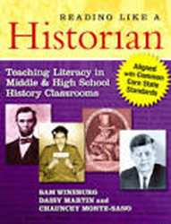
READING GUIDE
*Be prepared to use/share your responses at the February 18th SSTLN meeting.

- Read the introduction to Reading Like a Historian (pages ix-xii).

- Respond to these prompts in your journal/notebook:

  - How do I currently engage students in sourcing, contextualization and domain-specific literacy?

  - How can I incorporate the strategies for helping struggling readers read like a historian?

  - Visit the websites listed in the last paragraph of the Introduction. How can I use the lessons included in this book as well as the resources found on these websites in my classroom?

  - What other thoughts, reactions or questions do you have about this Introduction or this approach?

